**Advance Data Science/Architecture**

ArcGIS

Submitted By:

Karan Millan Thevar (**https://www.linkedin.com/in/karanmthevar/**)

Pratik Patre (**https://www.linkedin.com/in/pratikpatre/**)

Rahul Chandra (**https://www.linkedin.com/in/chandra-rahul/**)

(Team 3)

Under the Supervision of:

Prof Srikanth Krishnamurthy

**What is GIS?**

A geographic information system (or GIS) is a system designed to capture, store, manipulate, analyze, manage, and present spatial or geographic data.

A GIS centrally stores information about the world in a collection of map layers. Rather than having information in many formats stored in multiple places like filing cabinets, different computer systems, large binders or static paper maps, a GIS pulls together very different pieces of information into one system.

These map layers may be overlaid and linked together to create maps, integrate information, visualize and compare scenarios, solve problems and more effectively manage resources.

For local governments, a GIS is a computer technology that combines geographic data and other types of information (names, classifications, addresses and much more) to generate visual maps, reports, answer important questions and solve problems. A GIS uses geographic location to relate otherwise disparate data and provides a systematic way to collect and mange location-based information crucial to local government.

There are 3 views of GIS:

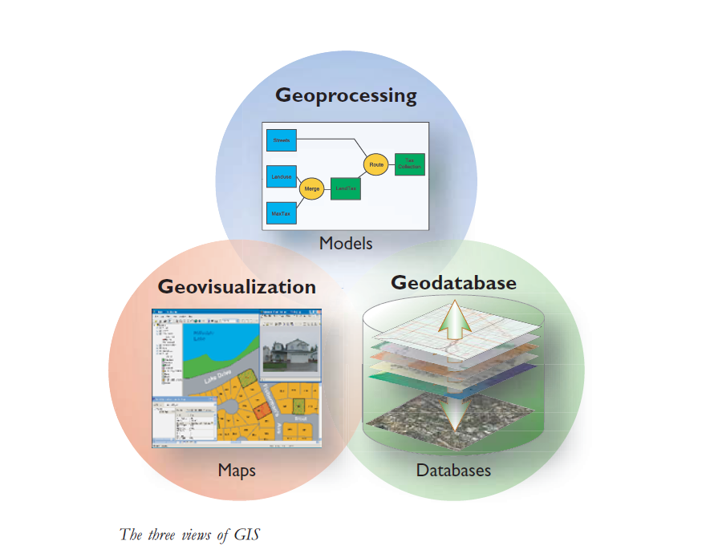

* **The geodatabase view:** A GIS manages geographic information. One way to think of a GIS is as a spatial database containing datasets that represent geographic information in terms of a generic GIS data model— features, raster’s, attributes, topologies, networks, and so forth.
* **The geovisualization view:** A GIS is a set of intelligent maps and other views that show features and feature relationships on the earth's surface. Various map views of the underlying geographic information can be constructed and used as windows into the geographic database to support query, analysis, and editing of geographic information. Each GIS has a series of two-dimensional (2D) and three-dimensional (3D) map applications that provide rich tools for working with geographic information through these views.
* **The geoprocessing view:** A GIS is a set of information transformation tools that derive new information from existing datasets. These geoprocessing functions take information from existing datasets, apply analytic functions, and write results into new derived datasets. Geoprocessing involves the ability to string together a series of operations so that users can perform spatial analysis and automate data processing—all by assembling an ordered sequence of operations.

**Introduction to ArcGIS:**

What is ArcGIS?

Developed by ESRI, ArcGIS is a comprehensive set of professional GIS tools for compiling, visualizing, analyzing, editing, managing, and sharing geographic data.

ArcGIS is an online geographic information system for using maps and geographic information everywhere—on desktops, in mobile devices, and in Web browsers. Various types of clients can be connected to a web of GIS services, providing information from thousands of GIS and mapping organizations worldwide. You can work with the system using a range of clients—GIS desktops, Web browsers, and mobile devices that are used to connect to and work with maps and geographic information services. These services can be hosted in a range of settings:

* On a local computer (and as files on disk)
* Published as GIS Web services for use within an enterprise
* Published and shared in the cloud

ArcGIS provides tools for mapping and spatial reasoning so you can explore data and share location-based insights. ArcGIS creates deeper understanding, allowing you to quickly see where things are happening and how information is connected.

**Capabilities**

ArcGIS offers a unique set of capabilities for applying location-based analysis to your business practices. Gain greater insights using contextual tools to analyze and visualize your data. Then share these insights and collaborate with others via apps, maps, and reports

* Spatial Analytics:

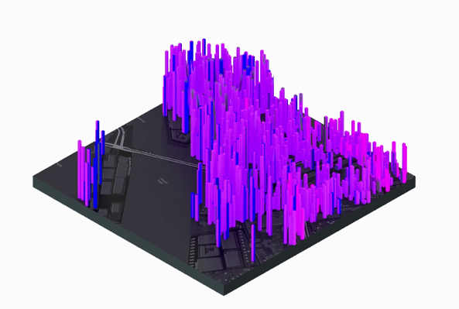Spatial analytics is the heart and soul of ArcGIS. You use it to find the best location for your business, plan for smarter communities, and prepare or respond faster in crucial situations.

* Mapping & Visualization:

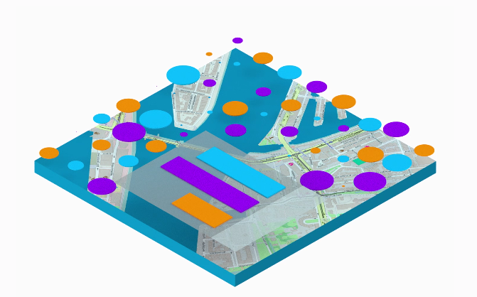Maps help you spot spatial patterns in your data so you can make better decisions and take action. Maps also break down barriers and facilitate collaboration. ArcGIS gives you the ability to create, use, and share maps on any device.

* 3D GIS:

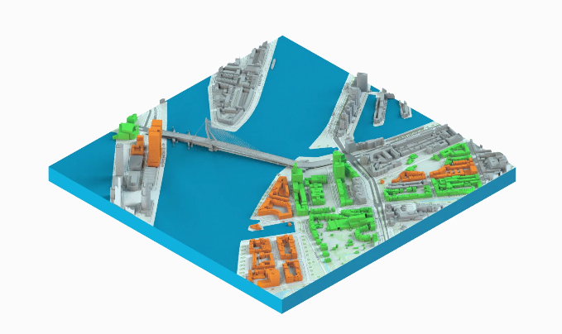3D GIS brings real-world context to your maps and data. Instantly transform your data into smart 3D models and visualizations that help you analyze and solve problems and share ideas and concepts with your team and customers.

* Real-Time GIS:

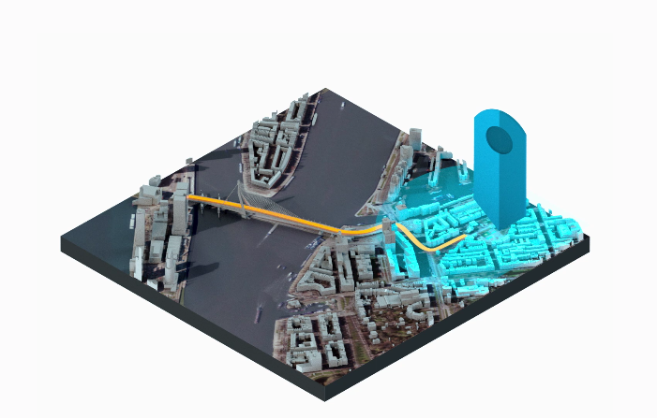Real-time GIS empowers you with location monitoring of any type of sensor or device — accelerating response times, optimizing safety, and improving operational awareness across all assets and activities, whether in motion or at rest.

* Imagery & Remote Sensing:

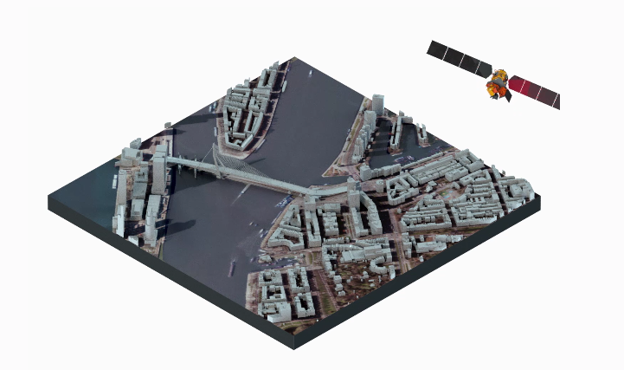ArcGIS gives you everything you need to manage, process, analyze, and share imagery. Not only do you get access to the world's largest imagery collection, you get tools like satellite, aerial, drone and full motion video.

* Data Collection & Management:

With ArcGIS, you can easily collect, crowdsource, store, access, and share your data efficiently and securely. You can integrate data stored in your business systems and geo-enable any data from any source.

**ArcGIS Frame Work:**

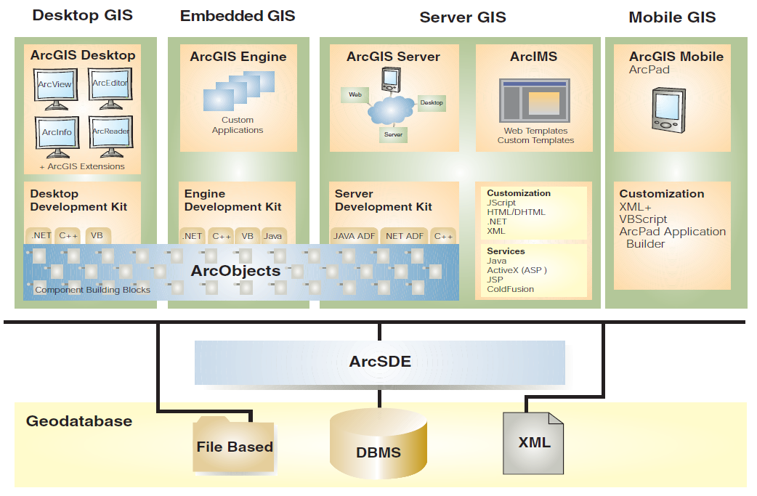

* **ArcGIS Desktop**: an integrated suite of professional GIS applications.

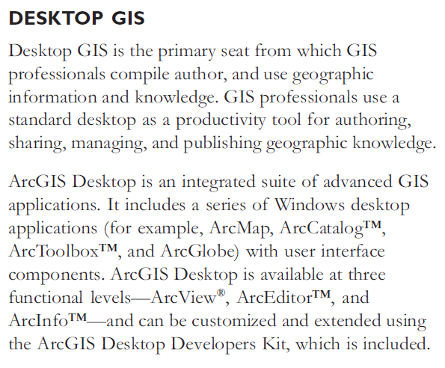

* **ArcGIS Engine**: embeddable developer components for custom GIS applications.



* **Server GIS**: ArcSDE, ArcIMS, and ArcGIS server.

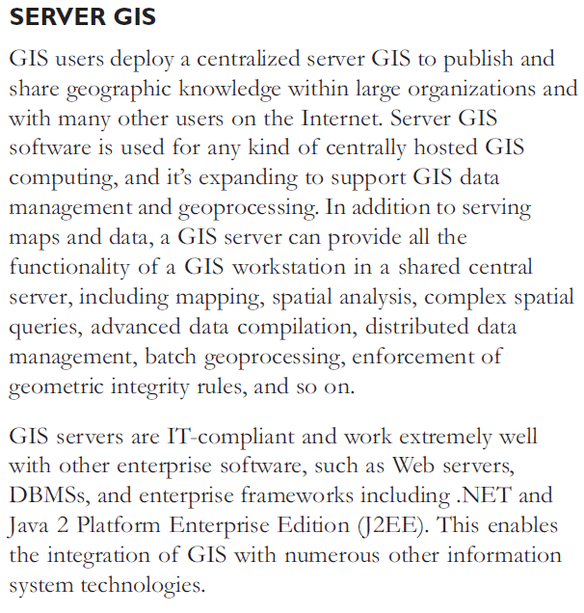

**Mobile GIS**: ArcPad as well as ArcGIS Desktop and Engine for Tablet PC computing

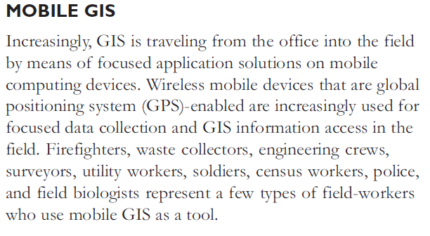

**ArcGIS Online**

ArcGIS Online is a key component and an integral part of [Esri](http://wiki.gis.com/wiki/index.php/Esri)’s [ArcGIS](http://wiki.gis.com/wiki/index.php/ArcGIS) system. It is a content management system comprised of applications and templates for creating interactive [maps](http://wiki.gis.com/wiki/index.php/Map). ArcGIS Online users can share maps within an organization or the world through ready-to-use tools that are available for the web, smartphones and tablets. Data, delivered as maps and information feeds, are accessible by other web developers and [GIS](http://wiki.gis.com/wiki/index.php/GIS) analysts who can share its contents through the same system. ArcGIS Online is mainly used by GIS professionals to publish information online – including geographic information, [cartography](http://wiki.gis.com/wiki/index.php/Cartography), analytics and [workflows](http://wiki.gis.com/wiki/index.php/Workflow).

**Features**

ArcGIS Online allows users to create, store and manage maps, applications and data. Esri and the GIS community can share maps, applications and data so that everyone has access to the information. For further details on other features of ArcGIS Online, visit ArcGIS Online Features.

**Mapping Tools**

ArcGIS Online provides various tools to analyze geographic information and convert data into information that are available with minor installation and setup. Users can control the

**Different types of maps**

published maps and applications through different channels: blogs, web pages and web applications such as Facebook, Twitter, and email. There are also ready-to-use analysis operations that work alongside with maps and applications to explore and measure geographic relationships such as creating buffers, driving times and dissolve boundaries.

**Basemaps**

ArcGIS Online comes with installed basemaps, demographic maps, imagery and map layers that become good foundations for users when working on maps. ArcGIS Online also includes a collection of maps on topics related to people, earth and life. The GIS user community from around the world contributes maps that other users can enrich with geographic information by adding layers to basemaps. Some of these maps are free while others require an ArcGIS Online paid or trial subscription.

**Ready-to-Use Applications**

**Applications for iPhone and Android smartphones**

There are a few applications which are available for download to all ArcGIS Online users. Collector for ArcGIS (iPhone and Android smartphones) is used to collect and improve data, attach photos and videos and also search for locations. Operations Dashboard for ArcGIS helps to monitor, track and report events. Users can make dynamic maps from Excel data and share through PowerPoint presentations using Esri Maps for Office. There is also Esri Maps for SharePoint, which allows users to view an organization’s data in a geospatial view through the SharePoint site. Users can access GIS data for maps’ collection and editing by using ArcGIS for Smartphones and Tablets.

**Data Protection**

ArcGIS Online secures all access to published information. User identity is established through a login process and when the users share maps online, the information is protected by multiple layers of security. The hosted web layers are secured based on the ArcGIS Online sharing model. By default, a hosted web layer is private when it is first published and is only accessible to the publisher [3]. Only when the user shares the information with a group of people using the standard sharing dialog boxes, the hosted web layer is accessible by the group. This is to control access towards data and maps which are constantly monitored and improved.

**Collaboration**

A workspace is available to team up with other users within the organization or the public. Users can create groups and invite others to share information. This workspace helps users to collaborate closely together by exchanging thoughts, design documentation, code, presentations, and other files in a secure and dedicated workspace.

Supported Browsers

[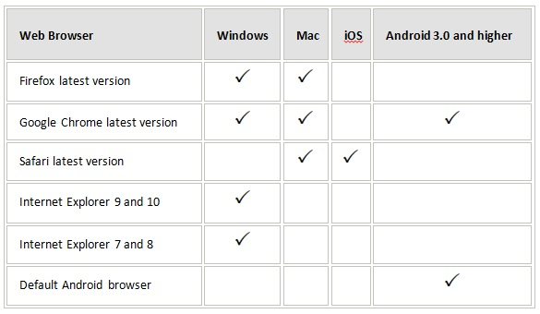](http://wiki.gis.com/wiki/index.php/File:SupportedBrowser.jpg)

**Hands On**

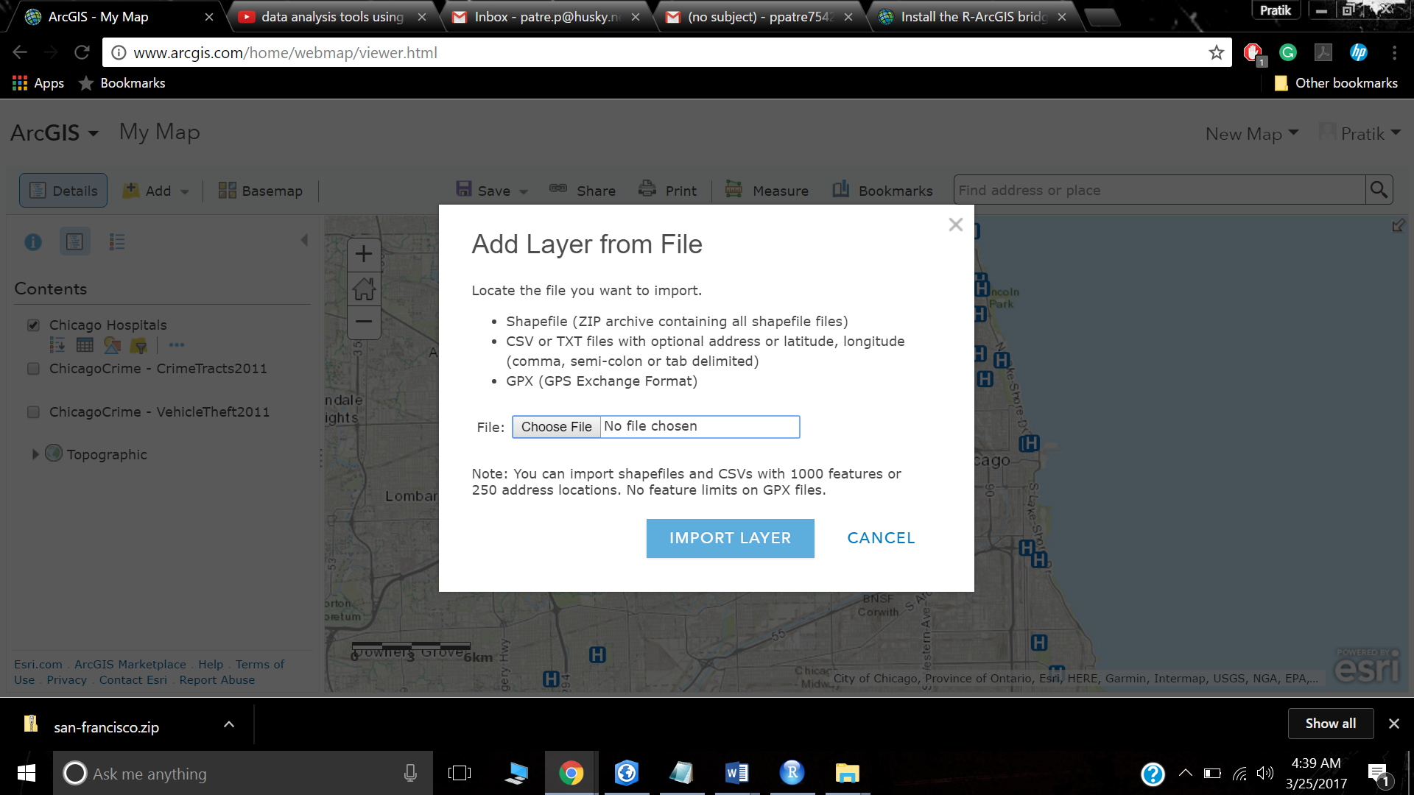

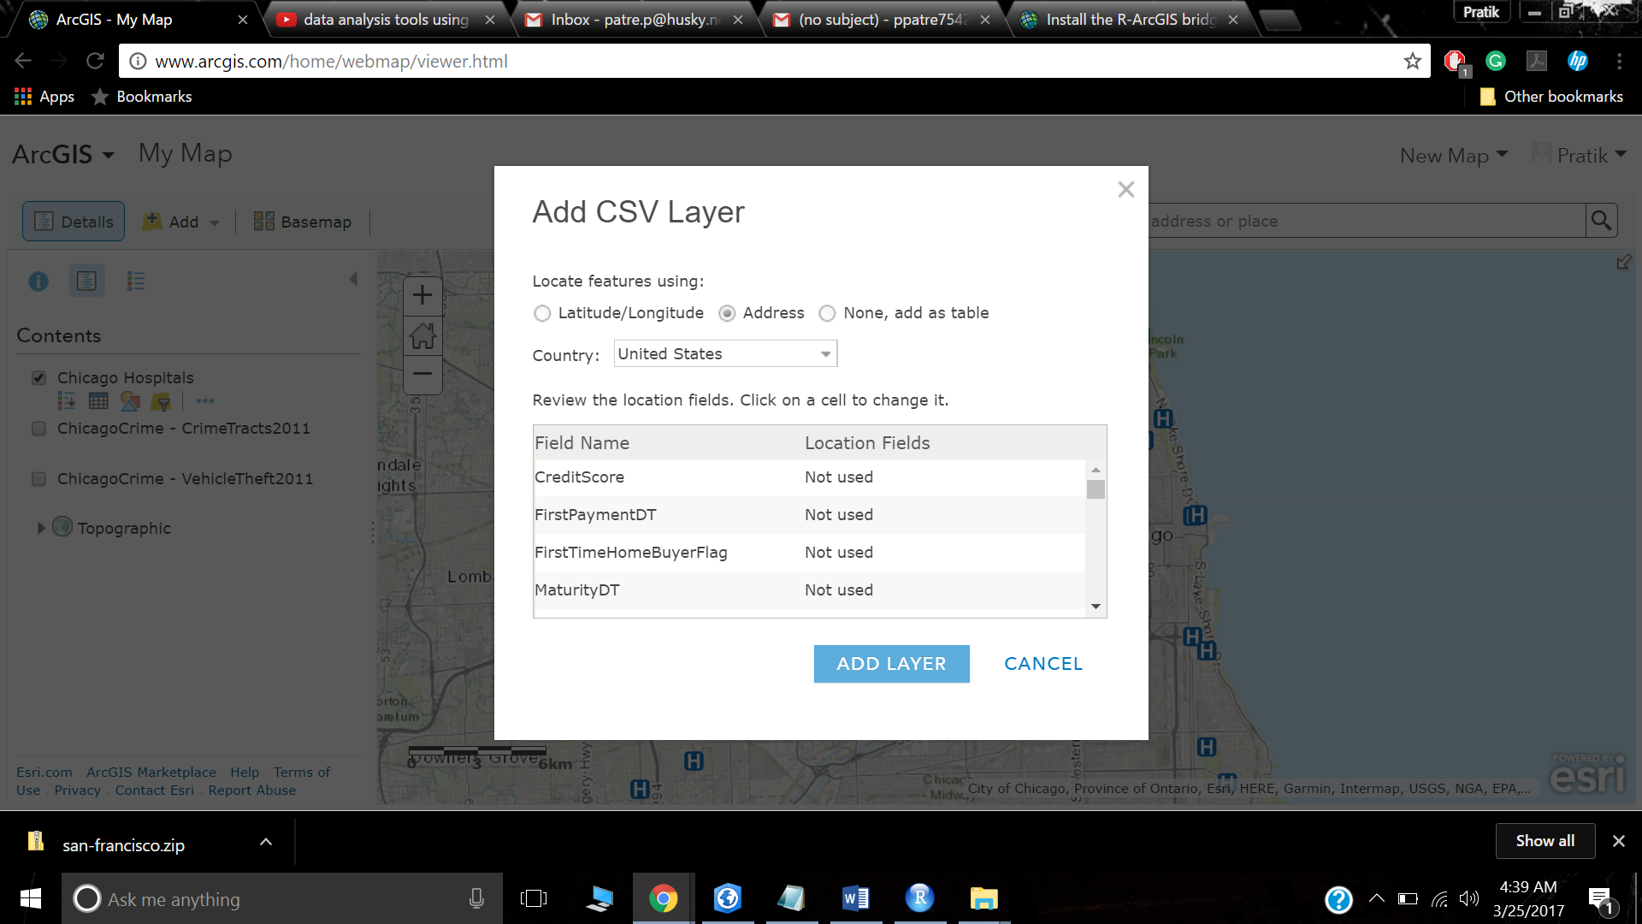

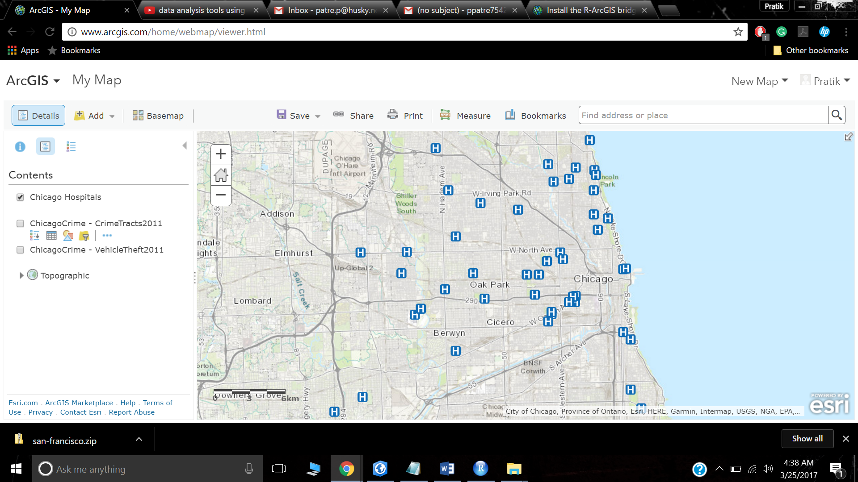

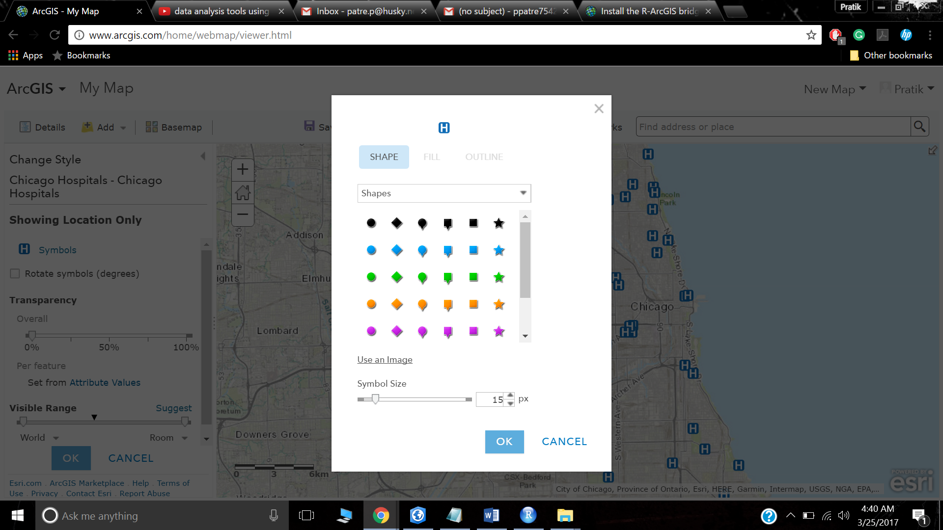

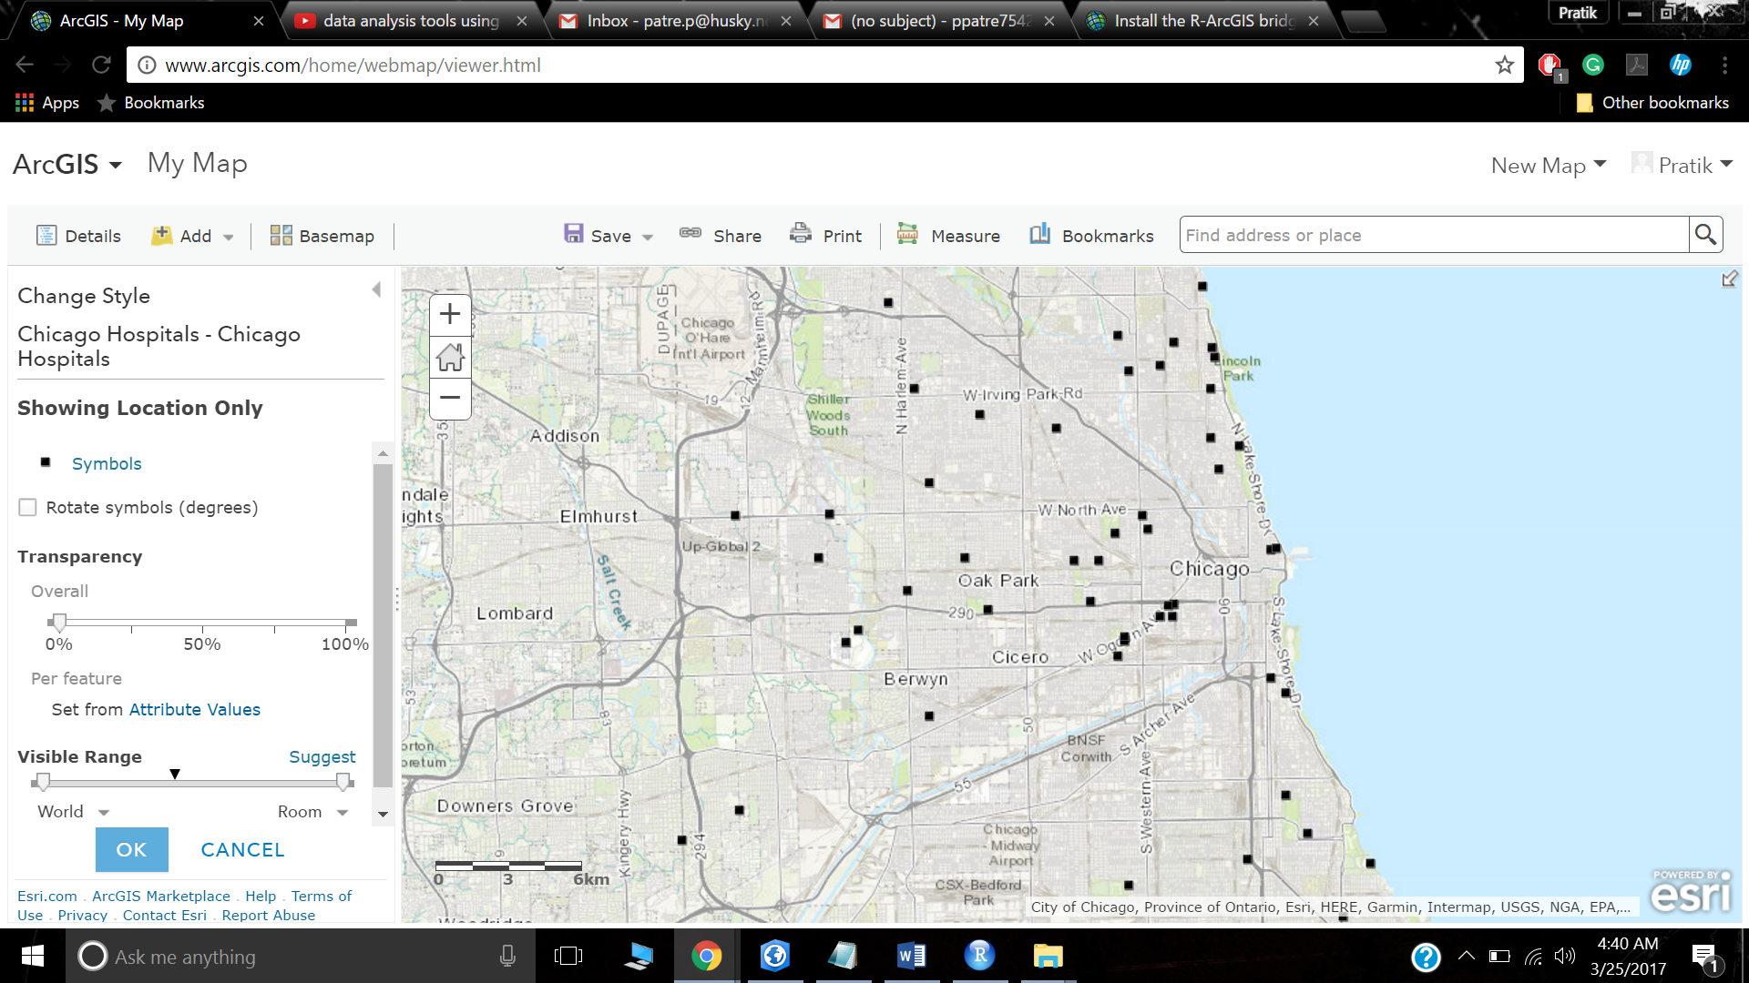

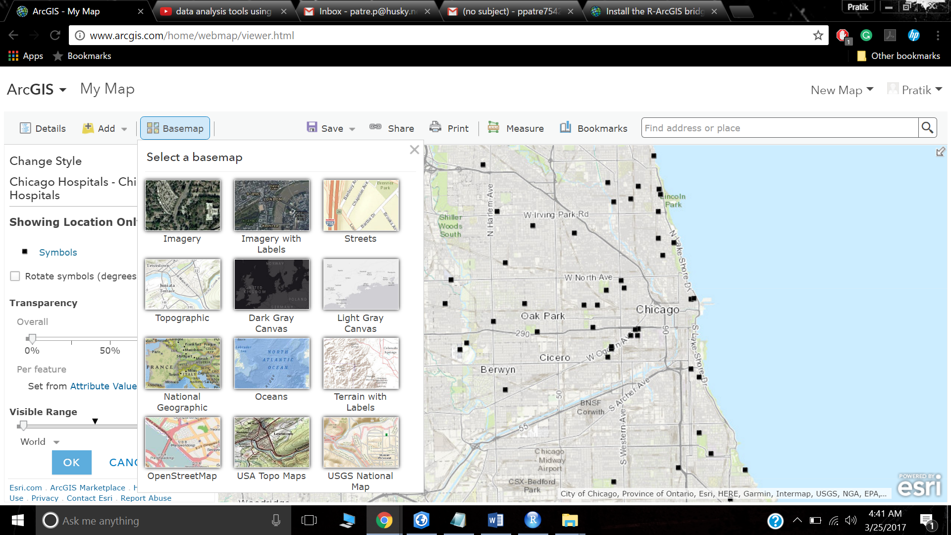

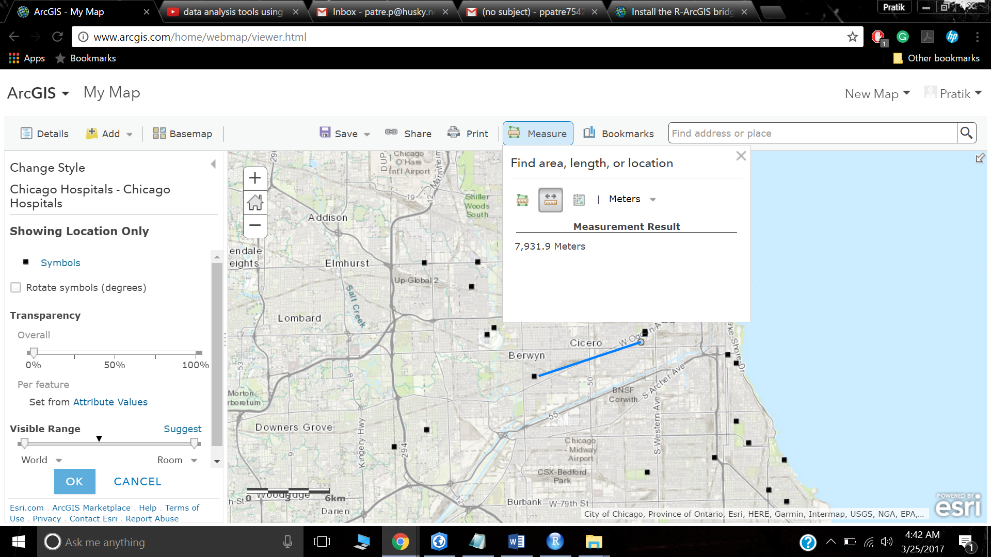

**CASE STUDY: Analyze Crime Using Statistics and the R-ArcGIS Bridge**

Overview

As a new GIS analyst at the San Francisco Police Department, you’re eager to help your supervisor develop a deeper understanding of the crime trends occurring in the city. The department supervisor uses ArcGIS for spatial analysis and R for statistical analysis, but she’s never used the two programs together. In addition, transferring data manually can be time consuming and as a result, the analyses are often kept separate.

R is a statistical programming language that is used all over the world to perform statistical analysis and predictive modeling due to its thousands of libraries containing a wealth of statistical methods. Your department uses its statistical analyses to identify patterns in events that otherwise may seem random and unconnected. This allows them to develop plans to properly allocate their resources and to reduce crimes. To combine the statistical libraries and functions of R with the spatial capabilities of ArcGIS, you’ll use the R-ArcGIS bridge.

Your supervisor is specifically interested in visualizing spatial and temporal trends of criminal activity, while considering factors that may affect unlawful behavior. Through the department’s previous research, some potential attributes have been identified that may influence the number of crimes in an area. The R-ArcGIS bridge allows you to seamlessly perform analyses on a single dataset by connecting the analytical tools from both programs simultaneously. You’ll perform statistical analyses to help test the department’s theories about the factors that affect unlawful behavior and identify the areas where higher numbers of crimes are likely to occur.

**Build skills in these areas:**

Setting up the R-ArcGIS bridge

Aggregating data based on areas and times of interest

Exploring temporal trends in a dataset

Enriching data to include additional attributes of interest

Performing data cleaning and maintenance

Transferring data between ArcGIS and R

Utilizing functions in R to perform statistical analysis

Exploring relationships between attributes in a dataset

**What you need:**

ArcGIS Pro

R 3.1.0 or later (64-bit)

RStudio Desktop

Working knowledge of ArcGIS Pro, R, and RStudio

**STEP: 1**

**Install the R-ArcGIS bridge and start statistical analysis**

Download the R-ArcGIS bridge, R, and RStudio

First, you'll install the R-ArcGIS bridge, which will allow you to work with R and ArcGIS simultaneously.

* Go to the [R-ArcGIS bridge installation page](https://github.com/R-ArcGIS/r-bridge-install).
* Click the **Clone or download** button and click **Download ZIP**.  A compressed file containing the R-ArcGIS bridge downloads onto your machine.
* Locate the downloaded file on your computer. Right-click the **r-bridge-install-master** zipped folder and choose **Extract All**. Note: Depending on your web browser, you may have been prompted to choose the file's location before you began the download. Most browsers download to your computer's Downloads folder by default.
* Extract to a location you can easily find, such as your Documents folder. A toolbox containing the R-ArcGIS bridge is now on your computer. Next, if you haven't already, you'll download and set up R and RStudio, a free integrated development environment for R. RStudio helps you work in R by providing a coding platform with access to CRAN, the Comprehensive R Archive Network, which contains thousands of R libraries, a built-in viewer for charts and graphs, and other useful features.
* If necessary, download [R 3.1.0 or later](http://cran.cnr.berkeley.edu/bin/windows/base/). Then, download [RStudio Desktop](https://www.rstudio.com/products/rstudio/download3/). Accept all defaults in the installation wizards. Now you'll add data to an ArcGIS project to create a map of San Francisco crimes.
* Download the [San-Francisco.zip file](http://downloads.esri.com/learnarcgis/analyze-crime-using-statistics-and-the-r-arcgis-bridge/san-francisco.zip).
* Locate the downloaded file on your computer and extract its contents to a folder named San-Francisco.
* Open the San-Francisco folder. The folder contains the SF_Crime geodatabase, which has crime data that you'll add to a map.
* Open ArcGIS Pro as an administrator. (Right-click and choose **Run as administrator**.) If prompted, sign in using your licensed ArcGIS account. Note: If you don't have ArcGIS Pro or an ArcGIS account, you can sign up for an [ArcGIS free trial](http://www.arcgis.com/features/free-trial.html).
* Create a new project named Crime Analysis and save it to your **San-Francisco** folder. In the **Create a New Project** window, uncheck the **Create a new folder for this project** box.
* In the **Project** pane, expand **Folders** and then expand the **San-Francisco** folder.
* Expand the **SF_Crime** geodatabase, right-click the **San_Francisco_Crimes** feature class, and choose **Add To New Map**. 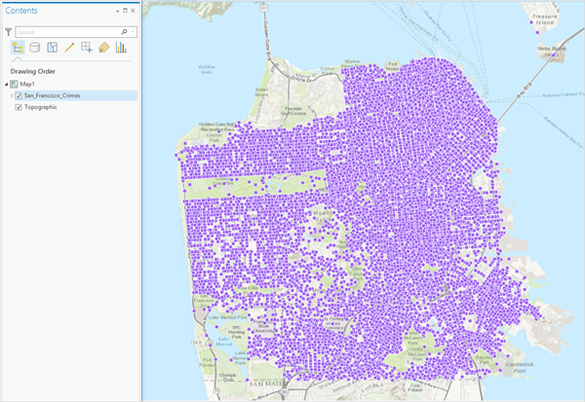 The map shows locations where crimes occurred from January 2014 through December 2014 in San Francisco.

Add the R-ArcGIS bridge toolbox to the project

The R-ArcGIS bridge appears as a toolbox in ArcGIS Pro and contains four Python scripts for installing and maintaining the R-ArcGIS bridge. These scripts appear as typical ArcGIS tools and can be used to perform various functions and checks on the bridge.

* In the **Project** pane, right-click **Toolboxes** and choose **Add Toolbox**.  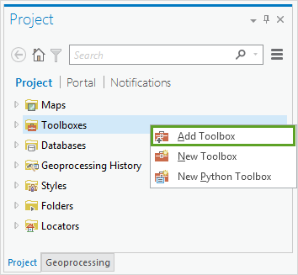
* Browse to the location of your extracted R-ArcGIS bridge folder. Click the **R Integration.pyt** toolbox and click **OK**.
* In the **Project** pane, expand the **R Integration** toolbox.  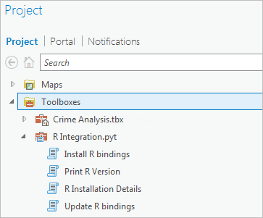
* Double-click the **Install R bindings** tool.
* Check the **Overwrite Existing Installation** box and click **Run**. The tool runs. When it finishes, the messages window indicates that the arcgisbinding package was successfully unpacked. The warning message informs you of the location where the arcgisbinding R package was installed.

Next, you'll return to the open map in ArcGIS Pro that contains the data on which you want to perform spatial and statistical analysis.

Aggregate point data by counts within a defined location

At first glance, the map may be overwhelming and difficult to understand what the data represents. Before you start your analysis, you need to aggregate crime counts by space and time. Aggregation reveals the spatial and temporal relationships in your data that may not have been visible before. Aggregating allows you to summarize your crime points in space-time bins that combine the crimes that have occurred into counts by space and time increments of your choosing.

* In the **Geoprocessing** pane, click the **Back** button.
* In the search box, type Create Space Time Cube and press Enter.
* In the results, click **Create Space Time Cube** to open the tool. Complete the following parameters:
  + For **Input Features**, choose **San_Francisco_Crimes**.
  + For **Output Space Time Cube**, browse to your **San-Francisco** folder and name the output San_Francisco_Crimes_Space_Time_Cube.nc.
  + For **Time Field**, choose **Dates**.
  + For **Time Step Interval**, type 1 and choose **Months**.
  + For **Time Step Alignment**, accept the default.
  + For **Distance Interval**, type 300 and choose **Meters**.
  + For **Aggregation Shape Type**, choose **Hexagon grid**.
* 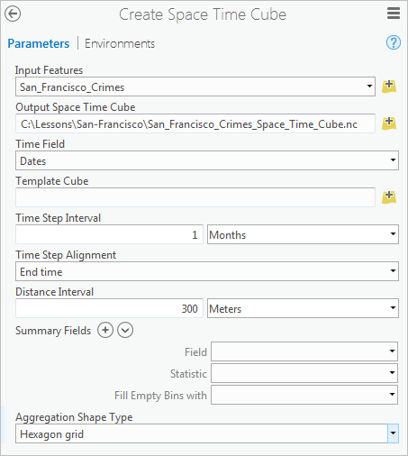  These parameter values specify the size and shape of the space-time bins that you are creating. Because your data is for the year 2014, analyzing crimes by each month is a natural breaking point. Additionally, your department wants to analyze crimes at a local level, so you select a small distance interval value. Hexagon bins are selected because they are preferable in analyses that include aspects of connectivity or movement paths.
* Click **Run**. The **Create Space Time Cube** tool creates a netCDF file, which allows you to view spatial patterns and trends over time. The tool aggregated the 74,760 points in the San_Francisco_Crimes layer into 3,510 hexagons (the polygon bins). Each hexagon represents an area of approximately 78,000 square meters. The **Distance Interval** and **Time Step Interval** parameters impact the number of resulting bins and the size of each bin. These values can be chosen based on prior knowledge of the analysis area, or the tool will calculate values for you based on the spatial distribution of your data. You can confirm that the **Create Space Time Cube** tool successfully created the file by checking the **Messages** window.

Analyze crime hot spots

Next, you'll analyze where statistically significant clusters of crime are emerging and receding throughout the city. Your analysis will help the department anticipate problems and evaluate the effectiveness of resource allocation for their crime prevention measures.

* In the **Geoprocessing** pane, search for and open the **Emerging Hot Spot Analysis** tool.
* Complete the following parameters:
  + For **Input Space Time Cube**, browse to and select the location where you stored your newly created space time cube.
  + For **Analysis Variable**, choose **COUNT**.
  + For **Output Features**, browse to your **San-Francisco** folder and name the output San_Francisco_Crimes_Hot_Spots.shp.
  + For **Neighborhood Distance**, **Neighborhood Time Step**, and **Polygon Analysis Mask**, accept the defaults.
* 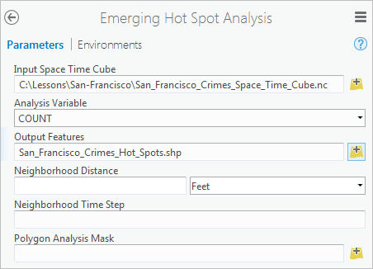  By using the default value for **Neighborhood Distance**, you are letting the tool calculate a distance band for you based on the spatial distribution of your data. The **Neighborhood Time Step** value is set to one time step interval (one month in this case) by default. These settings are ideal for an exploratory analysis; however, if you knew the optimal distance band or time step interval for your analysis, you could set them.
* Click **Run**. The tool runs and its results are added to the map. (The warning messages inform you of the values that the tool used for the **Neighborhood Distance** and **Neighborhood Time Step** parameters.)

Turn off the **San_Francisco_Crimes** layer to see the results more clearly. 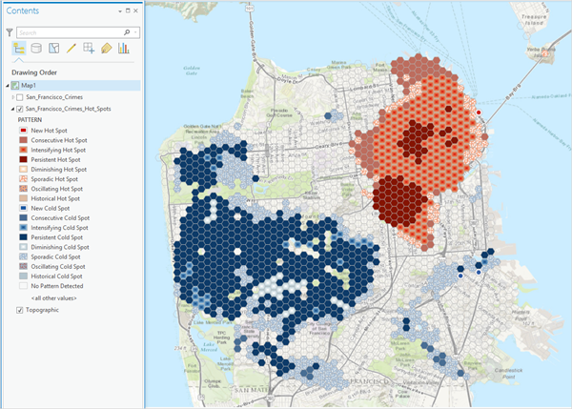 Trends in statistically significant hot and cold spots are shown on the map. Red areas indicate that over time there has been clustering of high numbers of crime, and blue areas indicate that over time there has been clustering of low numbers of crime. Each location is categorized based on the trends in clustering over time.  The dark red hexagon bins are persistent hot spots. These are locations that have been statistically significant hot spots for 90 percent of all of your time slices. However, these locations do not have a discernable increase or decrease in the intensity of clustering of crime counts over time.  In contrast, the light red with beige outlined hexagon bins are intensifying hot spots. These are locations that have been statistically significant hot spots for 90 percent of all of your time slices. In addition, these are locations where the intensity of clustering of crime counts is increasing over time, and that increase is statistically significant.  Conversely, the dark blue bins are persistent cold spots. These are areas where crime is statistically, and persistently, less prevalent. The light blue outlined bins are intensifying cold spots but means the opposite of its counterpart. Clusters of low crime counts in these cells are becoming more intense over time. In other words, the cold spots are getting colder. The department needs to be especially concerned about the areas where crime is persistent or intensifying. They may move resources to these areas from the places where crime cold spots occur.

**STEP: 2**

**Enhance your data with additional attributes**

Add additional attributes to your dataset

Now that you know where crime hot spots are emerging, you'll try to determine why they are emerging. In particular, you'll examine the relationship between an area's crime and its population. Statistical analysis can determine if the number of crimes occurring in a particular area is influenced by population. In addition, your department is interested in analyzing the presence of certain types of businesses, as well as the prevalence of parks, the amount of public land in a given area (hexagon bins), the median household income and home value, among other factors.

Currently, the hexagon bins in the space time cube layer contain no attribute information suitable for this kind of analysis. You'll run another geoprocessing tool to enrich the layer with relevant attribute information.

Note:

If your version of ArcGIS Pro is earlier than 1.4, you'll need to subset the data into two smaller pieces because the **Enrich Layer** tool may not run successfully on a dataset with over 1,000 rows.

* Run the **Enrich Layer** tool with the following parameters. Caution: This step requires approximately 50 ArcGIS service credits. If you don't have sufficient credits allocated to your ArcGIS organizational account (or if you're not sure), you can use the result file provided in the **StepResult** folder. Instead of running the tool, add **San_Francisco_Crimes_Enrich.shp** to your map and then skip to the next step.
  1. For **Input Features**, choose **San_Francisco_Crimes_Hot_Spots**.
  2. For **Output Feature Class**, browse to your **San-Francisco** folder and name the output San_Francisco_Crimes_Enrich.shp.
  3. For **Country**, choose **United States**.
  4. For **Data Collection**, choose **Key US Facts**.
  5. For **Variables**, choose **2010 Total Population**, followed by **2016 Median Home Value, 2016 Median Household Income**, and **2016 Renter Occupied HUs**.
  6. For **Data Collection**, change the data collection value from **Key US Facts** to **Industry by NAICS Code**.Note: The North American Industry Classification System (NAICS) is the convention used by Federal statistical agencies for classifying various businesses when collecting data for analyses and publishing.
  7. For **Variables**, in the drop-down box below the **2016 Renter Occupied HUs** box, choose **Food & Beverage Stores Bus**. In the next box, choose **Food Srv/Drinking Places Bus**.
  8. For **Data Collection**, change the data collection value from **Industry by NAICS Code** to **Landscape Facts**.
  9. For **Variables**, choose **% Forest (NLCD)**.
* 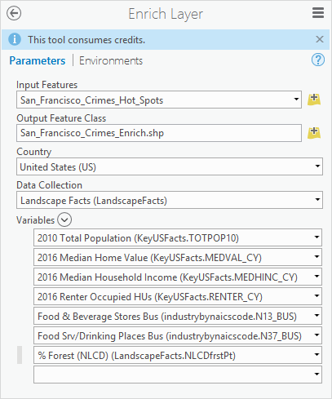  While not an exhaustive list of the variables that could potentially be linked to crime rates, this list will provide a good start for your analysis. Next, you'll take a look at the results.
* In the **Contents** pane, right-click the **San_Francisco_Crimes_Enrich** layer and choose **Attribute Table**.
* If necessary, scroll to the right in the attribute table until you can see the last eight columns.  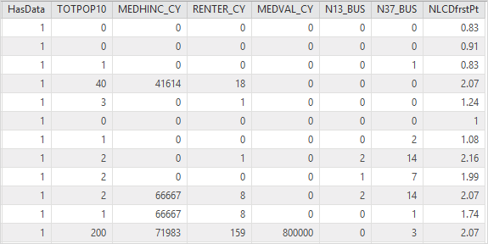  The result of the **Enrich Layer** tool includes the following columns and values:
  1. **HasData**—Indicates whether the Enrich Layer tool found data for the given hexagon bin, with 0 meaning a hexagon had no available data for all of the attributes you selected and 1 meaning a hexagon bin had data for at least one of the attributes you selected. You can use this field to filter your data so that only features with relevant attribute information appear on the map.
  2. **TOTPOP10**—Contains the population count per hexagon bin. Notice that some hexagons have a population of 0. A hexagon bin may have a population of 0 because it is located in an industrial area or in a park. The first priority of your department is to reduce crimes in populated areas, so you'll focus only on populated locations.
  3. **MEDHINC_CY**—Contains the median household income value per hexagon bin.
  4. **RENTER_CY**—Contains the number of renter occupied households per hexagon bin.
  5. **MEDVAL_CY**—Contains the median home value per hexagon bin.
  6. **N13_BUS**—Contains the count of food and beverage stores located within each hexagon bin.
  7. **N37_BUS**—Contains the count of businesses that serve food, beverages, or both located within each hexagon bin.
  8. **NLCDfrstPt**—Contains the percentage of land within each hexagon bin that is classified as forest land by the National Land Cover database.

You’ve created a dataset that contains the information needed to perform your analysis, but you now have some data that is not pertinent to your analysis goals. Hexagon bins that do not have information for your attributes of interest do not add any value or new information to help you answer your questions. Additionally, areas that are not populated are not of high priority for your department at this time. As a result, you'll need to trim down your enriched dataset to contain only the information most useful to you.

Prepare your dataset for additional analyses

Next, you'll select the data that is relevant to your analysis and make a subset with only that information. This way, you still have access to all your enriched data should you need it for further analyses, but you can continue your current analysis with only the necessary data.

* In the **Geoprocessing** pane, search for and open the **Select Layer By Attribute** tool.
* For **Layer Name or Table View**, choose **San_Francisco_Crimes_Enrich**.
* For **Selection type**, make sure **New selection** is chosen.
* In the **Expression** box, click **Add Clause**.
* In the **Field** box, choose **HasData**.
* For the expression, choose **is Equal to** and type the value 0 in the value parameter box. Click **Add**.
* Click **Add Clause** again and add the expression **Or TOTPOT10 is Equal to 0**.
* Click the green check mark to confirm your SQL expressions are valid.  Note: For more information about writing SQL expressions, see [SQL reference for query expressions used in ArcGIS](http://pro.arcgis.com/en/pro-app/help/mapping/navigation/sql-reference-for-elements-used-in-query-expressions.htm).   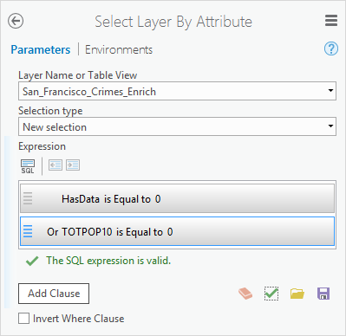
* Click **Run**. The tool runs and selects the rows that have no enriched data, or that have no population.
* If necessary, open the attribute table for the **San_Francisco_Crimes_Enrich** layer. You see that 231 of 1996 rows are selected, meaning they have 0 values for the HasData or TOTPOP10 fields. You'll create a new dataset without these selected features so you can focus on features that have data relevant to your analysis.
* In the attribute table, click the **Switch** button.  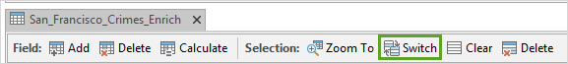  The button swaps the selection from the 231 rows that had no data or no population, to all of the other rows. You should have 1765 of 1996 rows selected, and you can now copy the enriched and populated data to its own layer.
* In the **Geoprocessing** pane, search for and open the **Copy Features** tool.
* For **Input Features**, choose **San_Francisco_Crimes_Enrich** When you have specific rows selected, the **Copy Features** tool only copies those rows into your new feature class result.
* For **Output Feature Class**, browse to your **San-Francisco** folder and name the output San_Francisco_Crimes_Enrich_Subset.shp.

Click **Run**. You now have two layers, San_Francisco_Crimes_Enrich and San_Francisco_Crimes_Enrich_Subset. The former contains the full dataset, and the latter contains only the data for areas with enriched attributes or areas with people living in them.

**STEP 3:**

**Perform statistical analysis using R and ArcGIS Pro**

Bridge your data into R

Next, you'll work in RStudio to perform Empirical Bayes smoothing on your crime rates. Because you have the R-ArcGIS bridge, the data in your ArcGIS Pro project is connected to and accessible from RStudio.

* If necessary, open your Crime Analysis project in ArcGIS Pro, and then open RStudio.  Next, you'll run a command that loads all the functions for the arcgisbinding package. Then you'll run another command that performs a quick check to ensure that the bridge is running correctly and that R recognizes the version of ArcGIS Pro you're using.
* In the R console, type the following code and press Enter:   library(arcgisbinding)
* In the R console, type the following code and press Enter:  arc.check_product()    The arc.check_product() function causes the RStudio Console to print information regarding your ArcGIS product and license.  After the arcgisbinding package has been loaded into the RStudio workspace and the connection from R to ArcGIS has been initialized, data from your current project in ArcGIS can be loaded into the RStudio workspace. Shapefiles, feature classes from geodatabases, and tables are all valid arguments to use in the open function.
* Use the arc.open() function. For its argument, type the full path to your enriched data subset (San_Francisco_Crimes_Enrich_Subset.shp) and press Enter. Note: You may have saved your project data to a different location than shown in the code example. If you're copying and pasting the code, update the path accordingly.   enrich_df <- arc.open(path = 'C:/Lessons/San-Francisco/San_Francisco_Crimes_Enrich_Subset.shp')    The open function returns a new arc.dataset class object, which you stored in the variable enrich_df. This object contains both the spatial information and the attribute information for your ArcGIS data and can now be used in other functions.  With the arc.select() function, you can choose a subset of attributes from the enrich_df object that you want to use as data for your analysis.
* Use the arc.select() function. For the first argument, put enrich_df as the object you're making a subset from. For the second argument, add a character vector containing the name of each attribute from your dataset that you want in your subset and press Enter.  enrich_select_df <- arc.select(object = enrich_df, fields = c('FID', 'SUM_VALUE', 'TOTPOP10', 'MEDHINC_CY', 'RENTER_CY', 'MEDVAL_CY', 'N13_BUS', 'N37_BUS', 'NLCDfrstPt'))    Your enrich_select_df variable now contains an R data frame object with the nine attributes you selected from your full original shapefile in R. These attributes include an ID value, the crime counts for each hexagon bin, and the seven attributes with which you enriched your data.  Finally, you’ll convert your R data frame into a spatial data frame object using the arc.data2sp() function. A spatial data frame object is one of the spatial data classes contained in the sp package. The sp package offers classes and methods for working with spatial data such as points, lines, polygons, pixels, rings, and grids. With this function, you can transfer all of the spatial attributes from your data, including projections, from ArcGIS into R without worrying about a loss of information.  If you've never used the sp package, you need to install the sp package into your RStudio package library, and load the functions from the sp package into your workspace environment.
* Use the library() function to load the sp package into RStudio. If necessary, uncomment the install.packages("sp") line.  #install.packages("sp")
* library(sp)
* Use the arc.data2sp() function. For the first argument, use the enrich_select_df data frame as the object you are converting to an sp object.  enrich_spdf <- arc.data2sp(enrich_select_df)

Your data has been bridged from ArcGIS Pro to RStudio.

Calculate smoothed crime rates

All the information that you need to start your analysis is in place, but you may notice that the current attribute labels are cryptic and abbreviated. In R, you can change the names of the enriched attributes to make them easier to identify. Once that's complete, you'll perform an Empirical Bayes smoothing on the data.

* Create a character vector called col_names. For each item in the vector, provide the new attribute name with which you want to replace the current label.  col_names <- c("OBJECTID", "Crime_Counts",
* "Population", "Med_HomeIncome",
* "Renter_Count", "Med_HomeValue", "Grocery",
* "Restaurant", "Pct_Forest")
* Use the colnames() function. For its argument, select the data attribute of your spatial polygons data frame by using enrich_spdf@data. Assign the col_names vector that you created as the attribute label values to be assigned in place of the original variable names.  colnames(enrich_spdf@data) <- col_names    You have updated the column names for the data attribute of your spatial polygons data frame. To check your changes, you can view the first few lines of the data attribute by entering the following command in your R console:   head(enrich_spdf@data)     Next, you’ll use the EBest() function to perform Empirical Bayes smoothing on your crime rates. The EBest() function is contained in the spdep package. As before, if you've never worked with the spdep package, you’ll need to uncomment the install.packages("spdep") line and first load the package into your library before running the library(spdep) line to load the spdep package into your workspace.
* In the console, type the following lines of code to calculate Empirical Bayes smoothed crime rates for each hexagon bin. You can either run each line individually or paste the entire code block and run all the lines at once. Note: Copying and pasting code into the console can sometimes result in a syntax error. Type the respective lines of code to resolve the error.   #install.packages("spdep")
* library(spdep)
* n <- enrich_spdf@data$Crime_Counts
* x <- enrich_spdf@data$Population
* EB <- EBest (n, x)
* p <- EB$raw
* b <- attr(EB, "parameters")$b
* a <- attr(EB, "parameters")$a
* v <- a + (b/x)
* v[v < 0] <- b/x
* z <- (p - b)/sqrt(v)    Finally, you'll add your smoothed crime rates as a new attribute to your spatial data frame object.
* Create a new attribute called EB_Rate to your spatial polygons data frame by using enrich_spdf@data$EB_Rate and assign to it the numeric vector z, which contains your crime rates for each location.  enrich_spdf@data$EB_Rate <- z    Your data now contains a new column called EB_Rate that contains the crime rate values that you calculated above for each hexagon bin. Now that you're done in R, you'll return to ArcGIS to explore your newly created crime rates by mapping and analyzing them. First, you'll use the arc.sp2data() function to convert your data back from an R spatial data frame object to an ArcGIS file type. You'll then use arc.write() to write your data to your project of choice.
* Use the arc.sp2data() function and enter enrich_spdf as its argument. Assign the result to a new variable, such as arcgis_df and press Enter.  arcgis_df <- arc.sp2data(enrich_spdf)    Your R spatial polygon data frame has now been converted back to a data frame object and can be written to your ArcGIS project. You can write your data frame object back to your ArcGIS project as a shapefile, table, or feature class in a geodatabase.
* Use the arc.write() function. For the first argument, type the path to your SF_Crime geodatabase and name the feature class San_Francisco_Crime_Rates. For the second argument to the arc.write() function, enter the R object that you want to write to ArcGIS and press Enter.   arc.write('C:/Lessons/San-Francisco/SF_Crime.gdb/San_Francisco_Crime_Rates', arcgis_df)

Using R, you transformed your data into something much more powerful. You turned your crime counts for each hexagon bin into crime rates that account for changes in population and showed how that impacts the number of crimes that occur. You used Empirical Bayes smoothing to ensure that the rates you created were robust to the amount of information available for each location.

Next, you’ll reexamine your data in ArcGIS Pro so you can visualize the trends and patterns of crime.

Continue analysis in ArcGIS Pro

Now that it's time to bring your R-adjusted data back into ArcGIS, you'll minimize RStudio and maximize your ArcGIS project.

* Minimize RStudio and maximize ArcGIS Pro.
* In the **Project** pane, right-click your **SF_Crime** geodatabase and choose **Refresh**.  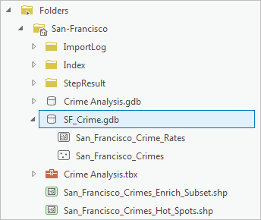  The SF_Crime geodatabase now includes the San_Francisco_Crime_Rates feature class, which contains the smoothed crime rates.
* Right-click the **San_Francisco_Crime_Rates** feature class and choose **Add To New Map**. The file is added to a map in your project and can be used for analysis.

Identify areas with unusually high crime rates

To see which areas in San Francisco have an unexpectedly high number of crimes given the number of people, you’ll run another hot spot analysis.

The first hot spot analysis you ran identified areas with statistically significant higher numbers of crimes than expected and provided information on how the number of crimes for each location were changing over time. This hot spot analysis identifies statistically significant clusters of high and low crime rates, allowing you to see the areas with usually high numbers of crimes given the population in the area.

* In the **Geoprocessing** pane, search for and open the **Optimized Hot Spot Analysis** tool.
* For **Input Features**, choose **San_Francisco_Crime_Rates**.
* For **Output Feature**, browse to your **San-Francisco** folder and name the output San_Francisco_Crime_Rates_OHSA.shp.
* For **Analysis Field**, choose **EB_Rate**. By running this tool on the crime rates that you calculated in R contained in the EB_Rate column, the results of this tool will locate the statistically significant spatial clusters of high or low crime rate values.
* Click **Run**.  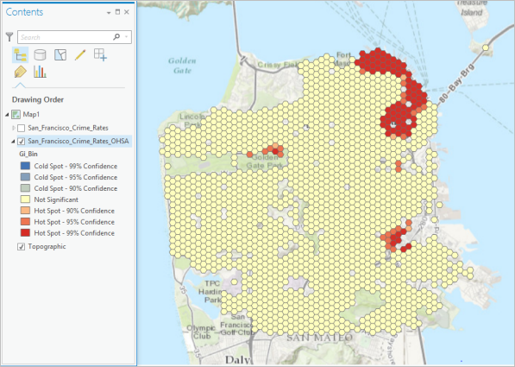  On your map, the bright red hexagon bins signify areas where there is intense clustering of high values with 99 percent confidence. These are areas where there are unusually high numbers of crimes occurring even when accounting for population. Notice that once the population of each area is considered, there are no statistically significant cold spots (areas of clustering of low crime counts).
* Save your project.

In this lesson, you used the R-ArcGIS bridge to transfer your data into R to taken advantage of functionality needed to calculate smoothed crime rates. You then transferred your data back into ArcGIS to continue your analysis and to further pinpoint areas in need of extra police resources to reduce the number of crimes occurring.

**OUTPUTS:**

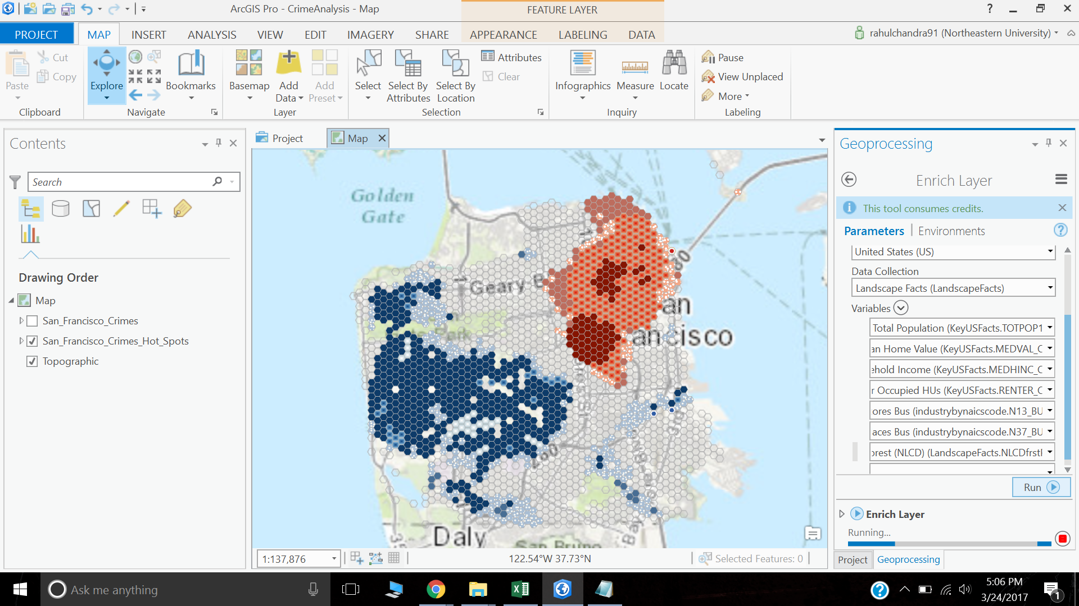

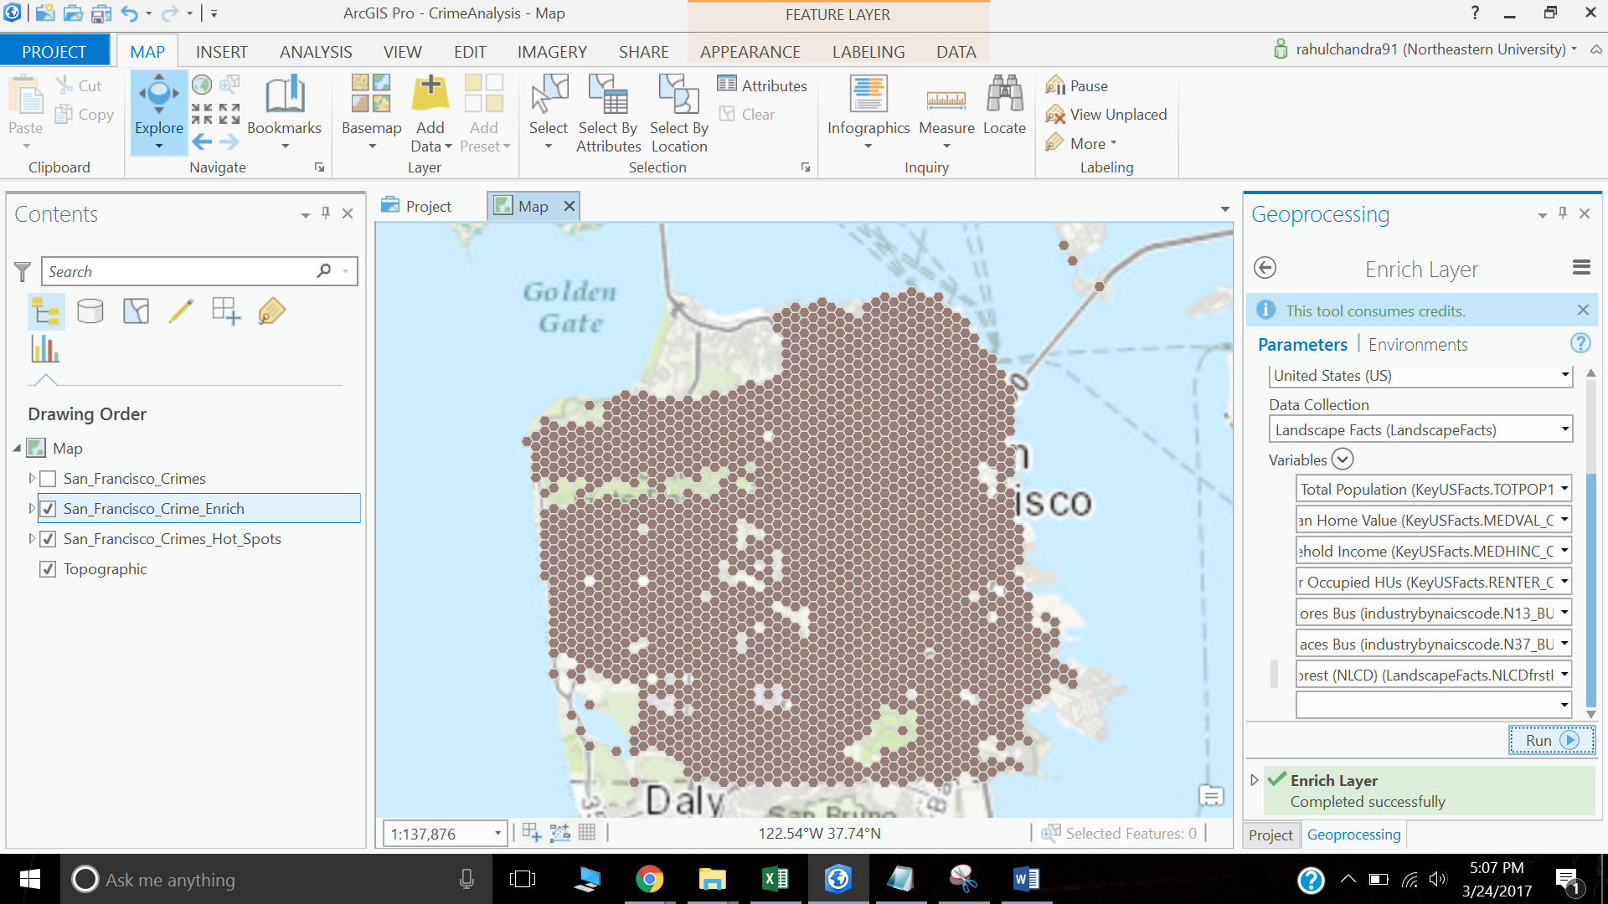

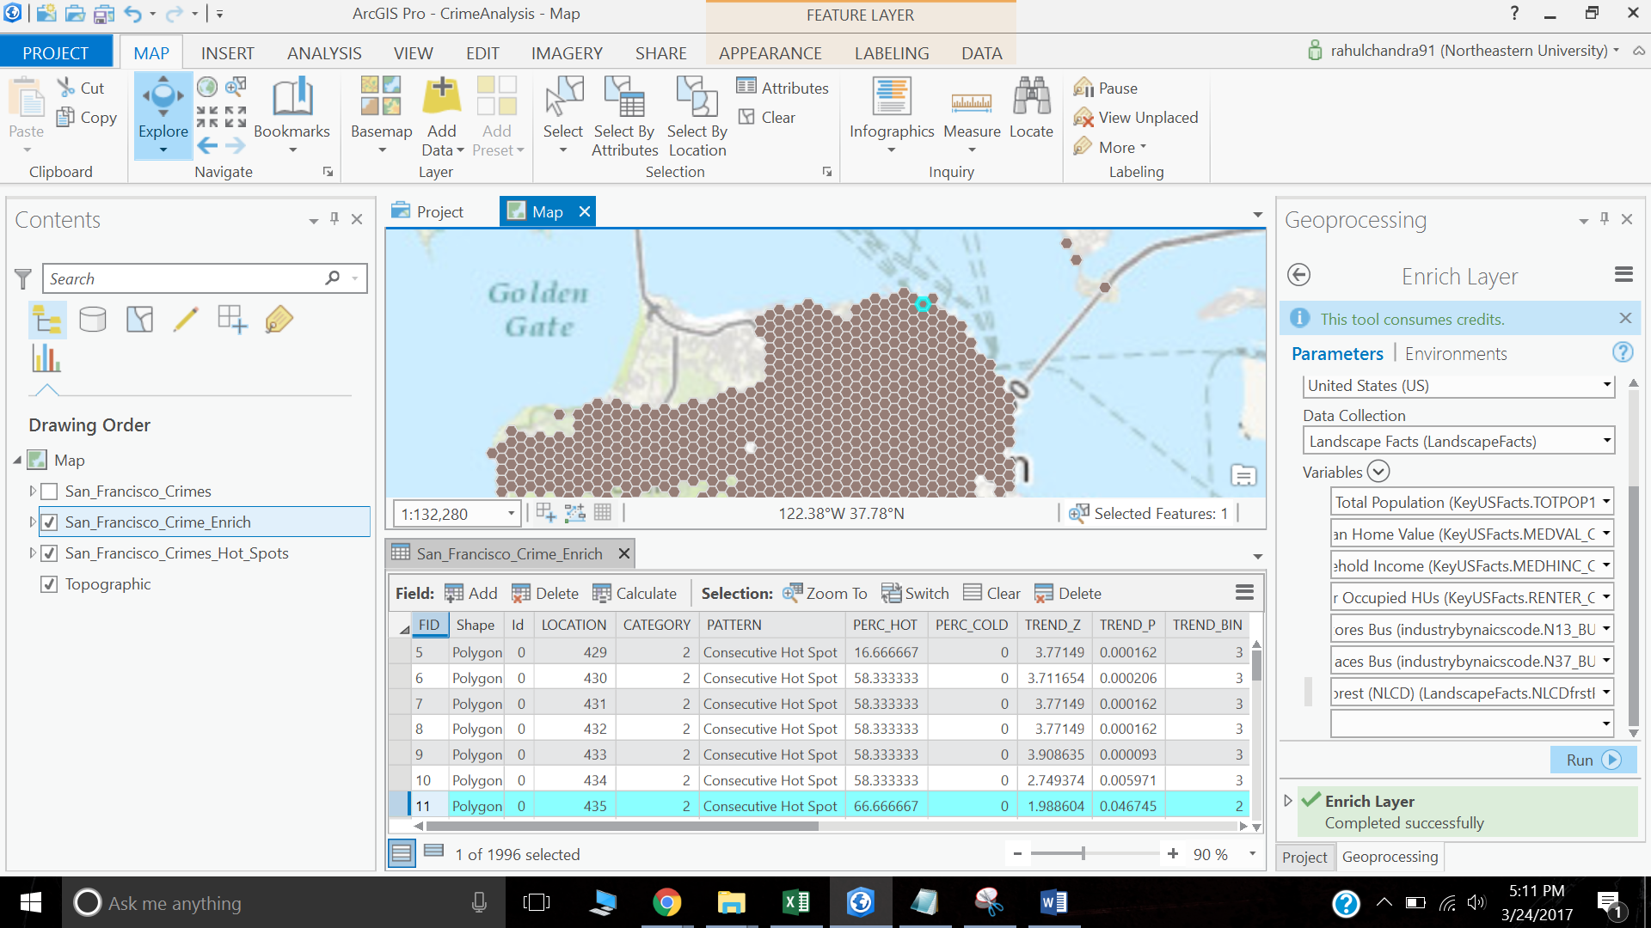

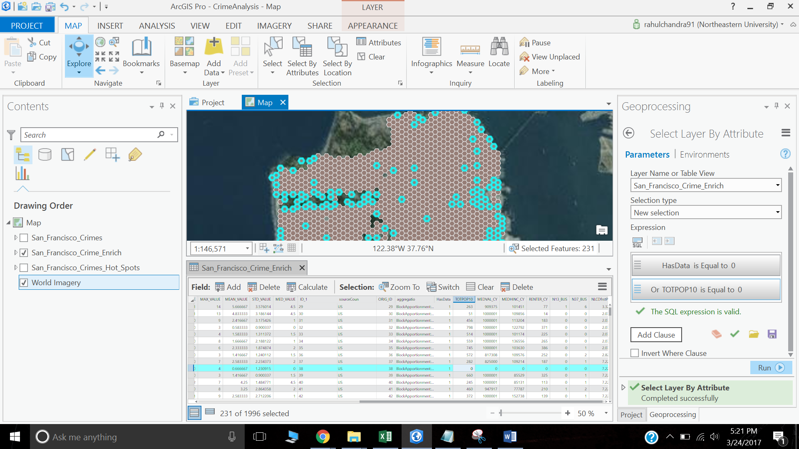

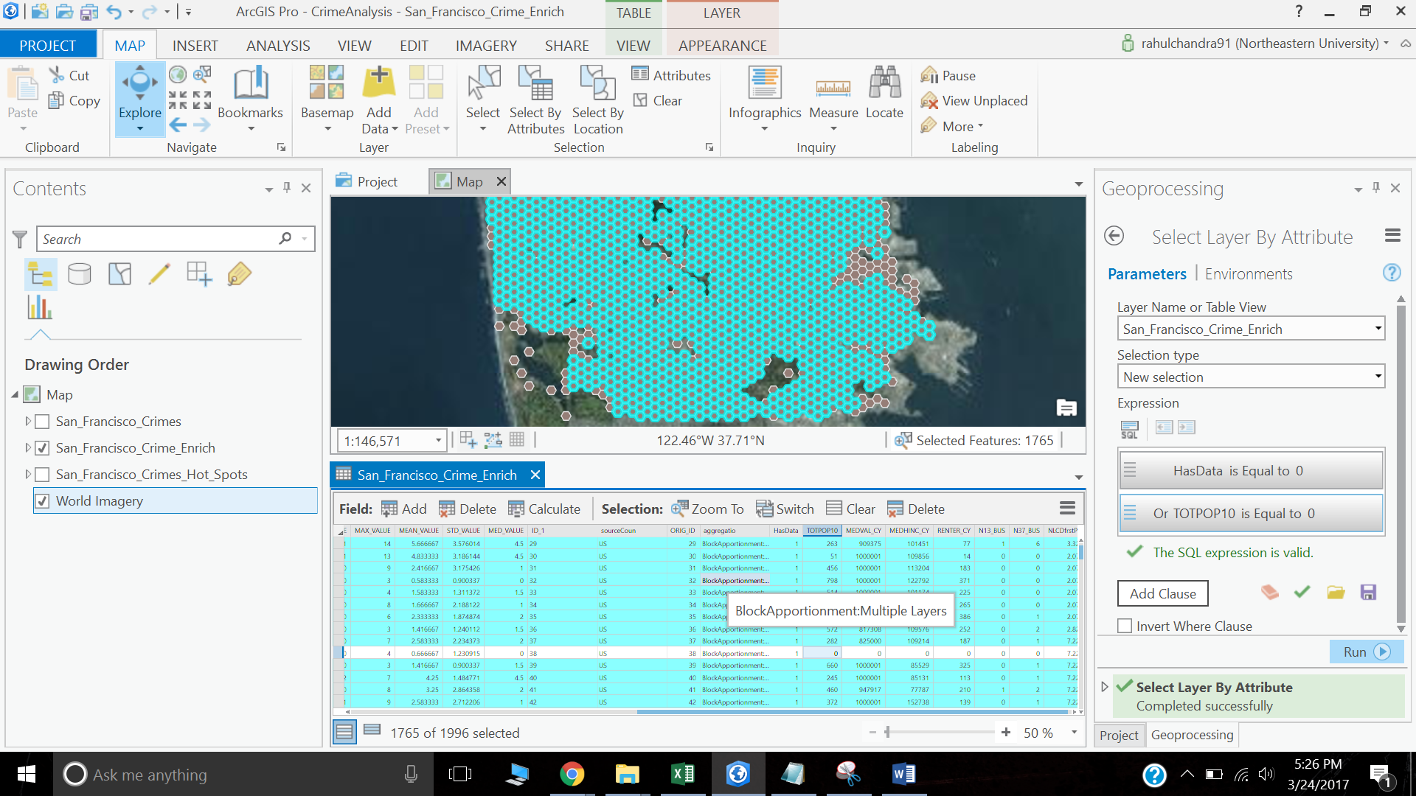

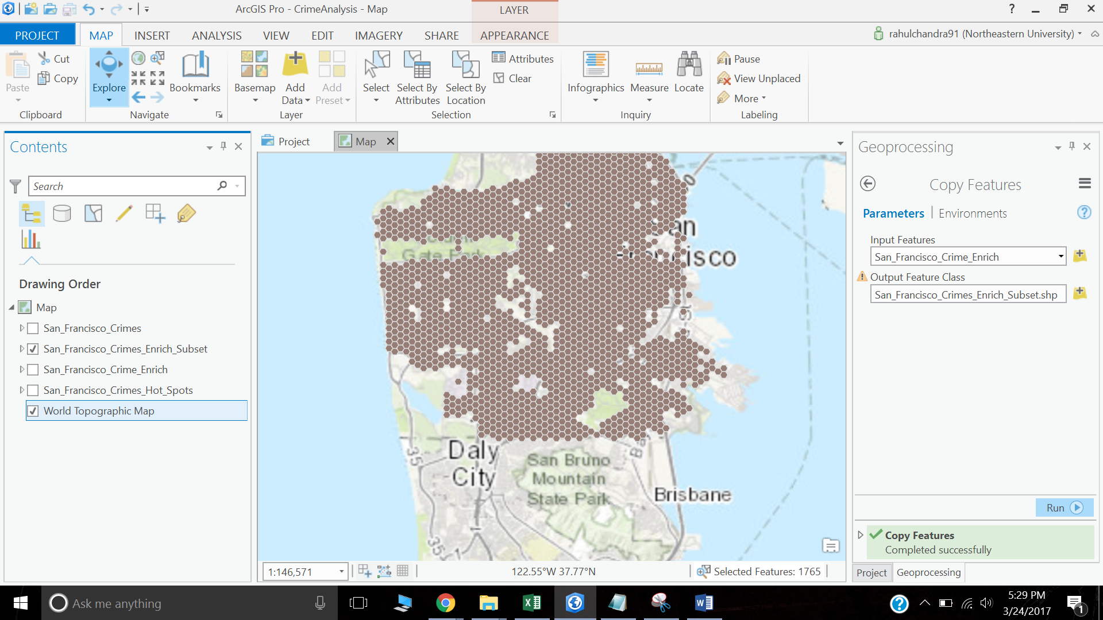

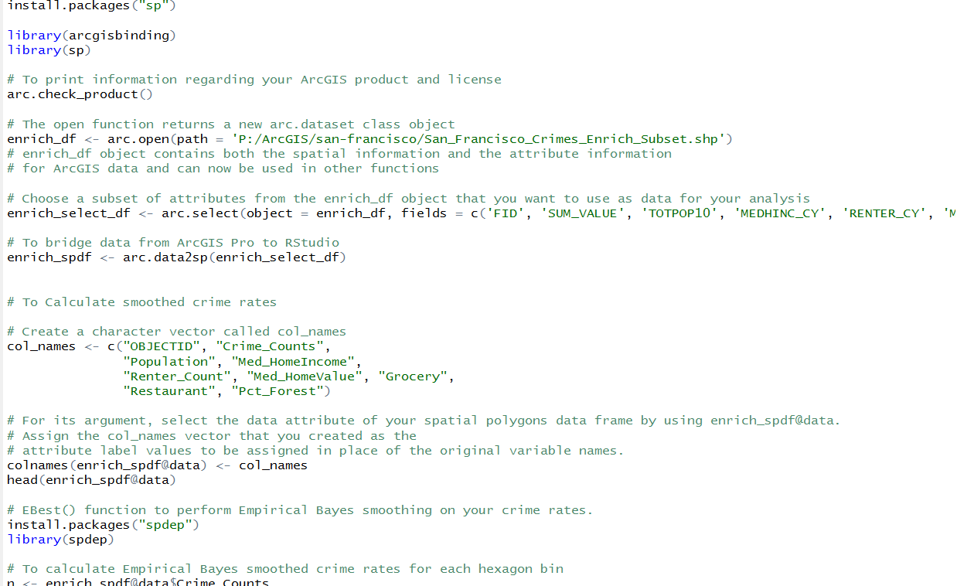

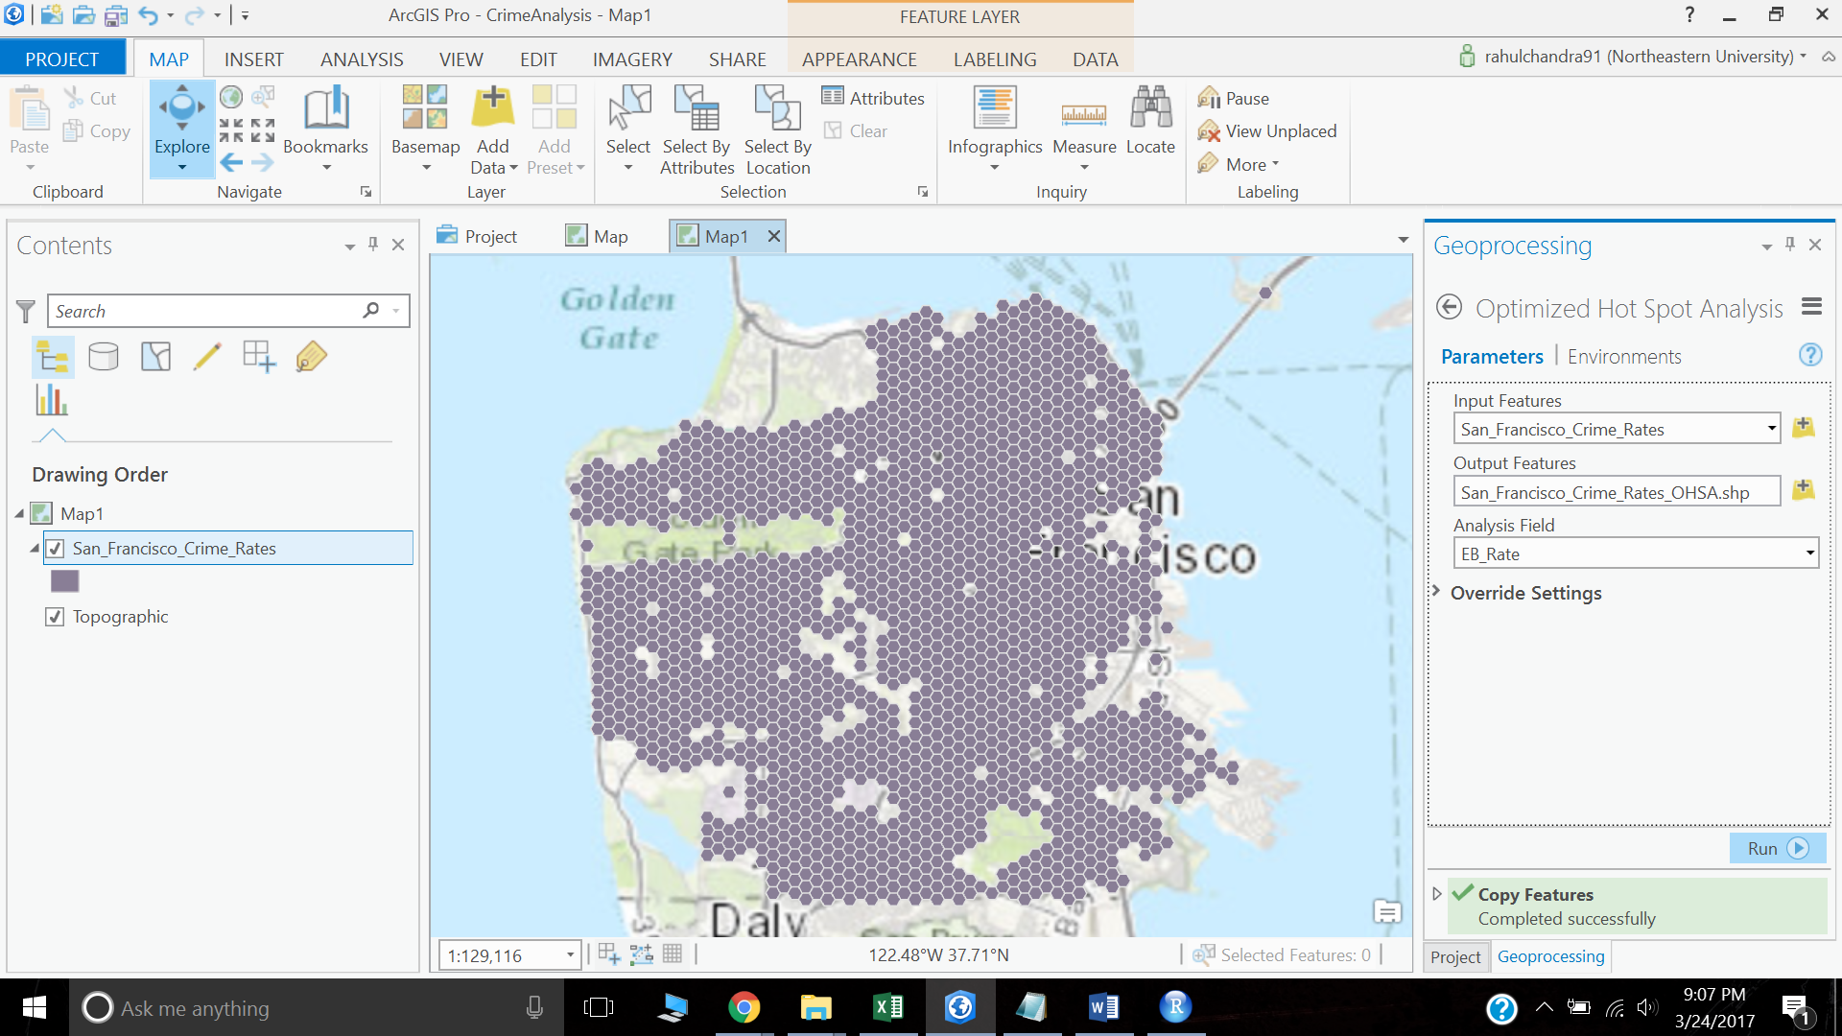

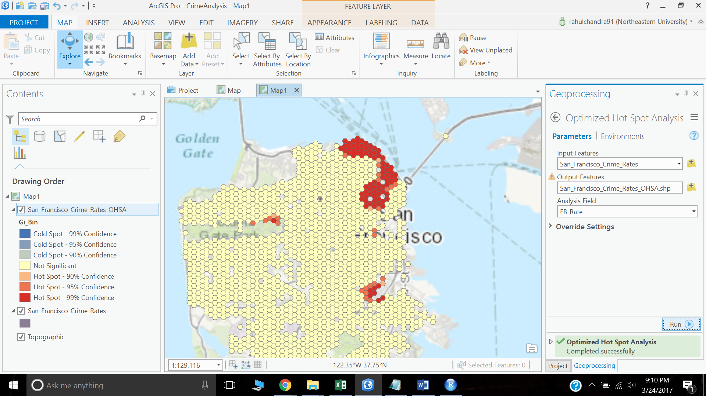

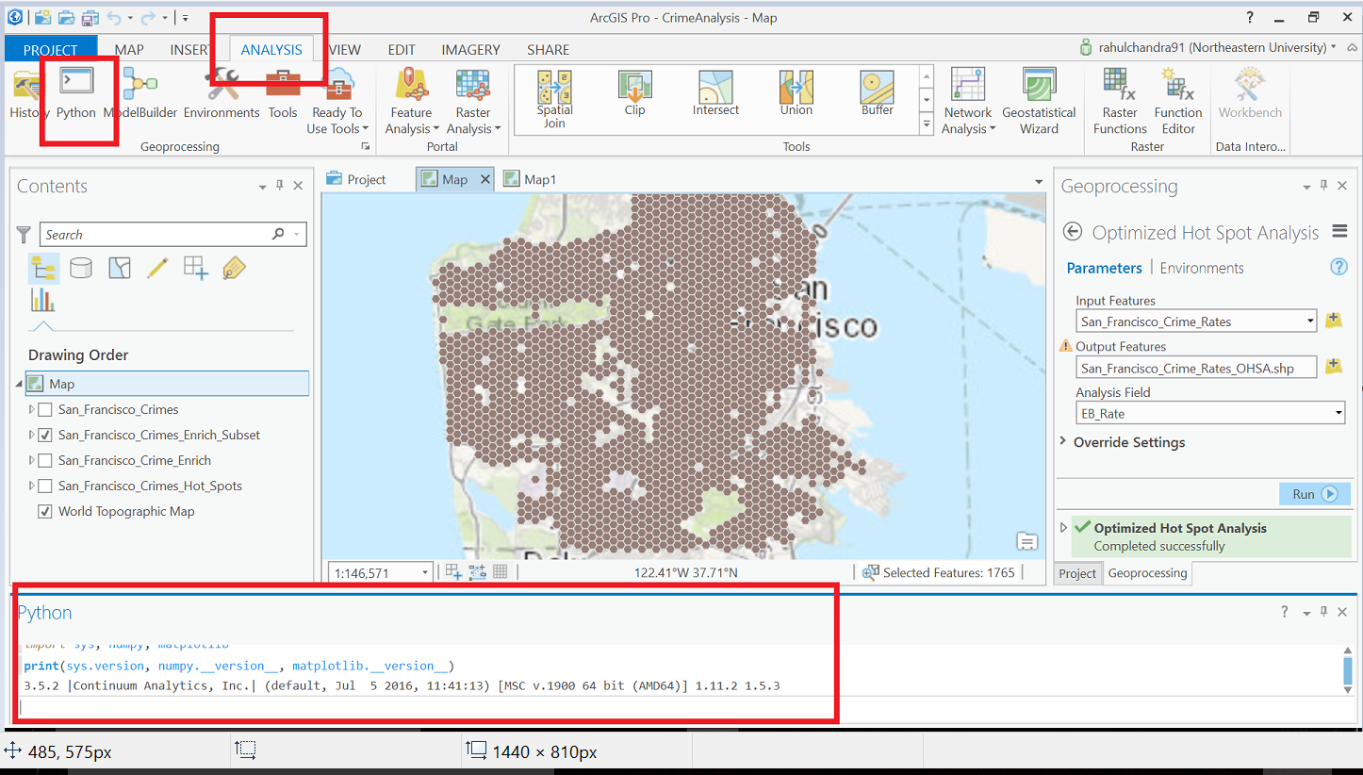

**PYTHON CODE – Using ArcPY**

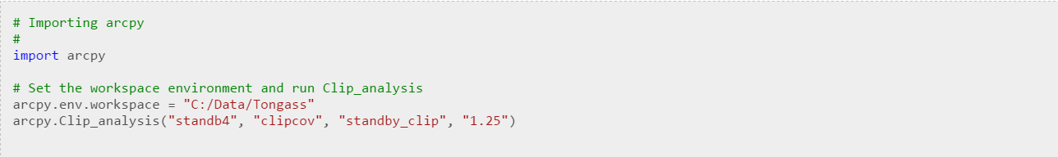



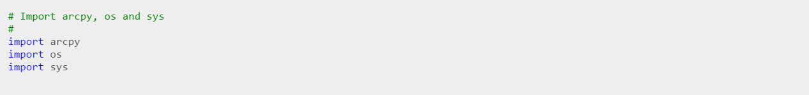

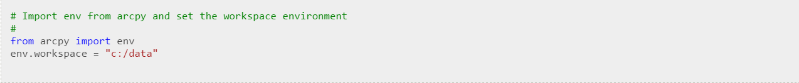

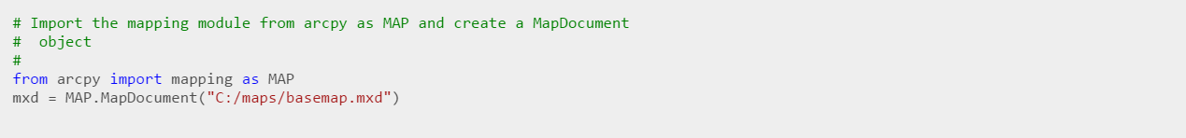



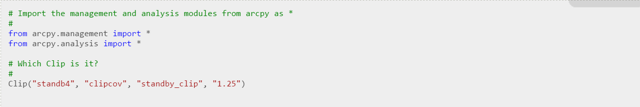

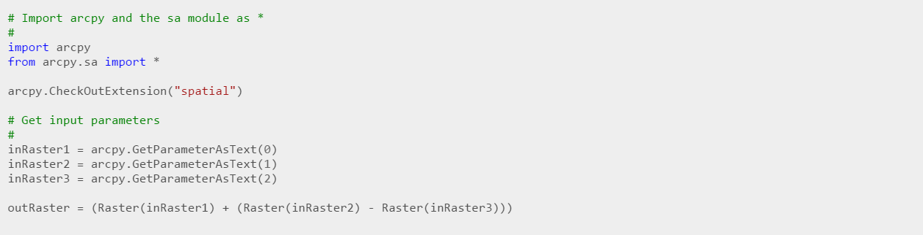

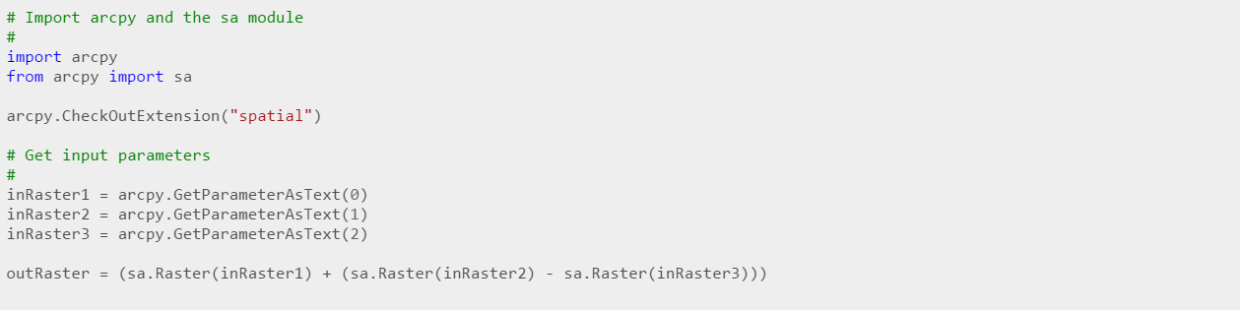

**Conclusion:**

Esri's transition to the ArcGIS platform, starting with the 1999 release of ArcGIS 8.0, rendered incompatible an extensive range of user-developed and third-party add-on software and scripts. A minority user base resists migrating to ArcGIS because of changes in scripting capability, functionality, operating system (Esri developed ArcGIS Desktop software exclusively for the Microsoft Windows operating system), as well as the significantly larger system resources required by the ArcGIS software. Esri has continued support for these users[citation needed]. ArcView 3.x is still available for purchase, and ArcInfo Workstation is still included in a full ArcGIS ArcInfo licence to provide some editing and file conversion functionality that has not been included to date in ArcGIS.[citation needed] Other issues with ArcGIS include perceived high prices for the products, proprietary formats, and difficulties of porting data between Esri and other GIS software.

There are other software that are present in the market like QGIS, MapInfo Professional, PostGIS, GrassGIS, etc.

References:

* Wikipedia links on ArcGIS
* <http://www.cosb.us/county-departments/geographic-information-systems-gis/#.WNY8HzsrI2x>
* <http://www.qgis.org/en/site/>
* <http://gisgeography.com/qgis-arcgis-differences/>
* downloads.esri.com/support/documentation/ao_/698what_is_arcgis.pdf

**Git link :**

https://github.com/rahchandra/DataScience/tree/master/ClassPresentation